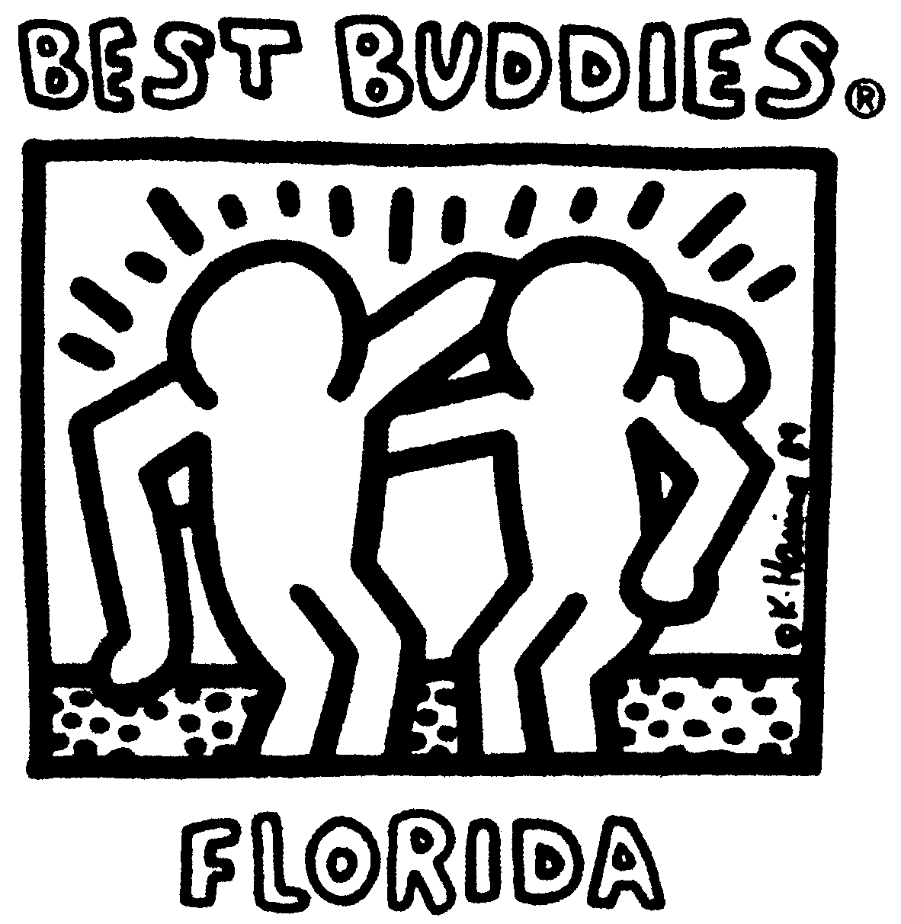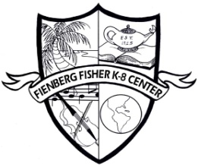

**ROCK THE WORLD: Spread the Word to End the WORD CAMPAIGN**

**EVENT Summary and Schedule**

**Friday March 23, 2012**

**Mission: We will use the Spread the Word to End the WORD Campaign to make people aware of the damaging effects of the use of the r-word. Our mission is to replace the R-WORD (Retard) with RESPECT!**

**8:30-9:00 Breakfast:**

**Invited Guests**

MDCPS School Board Member: Martin Karp

MDCPS Region Representative: Mr. Doltres

City of Miami Beach Mayor: Matti Bower

City of Miami Beach Commissioners

Fienberg-Fisher’s K-8 Center Best Buddies Administration and Faculty Members

Best Buddies Founder: Anthony Kennedy Shriver

Eunice Shriver

Chessy Shriver

Best Buddies Representatives: Madeline Spado, Anika Allen, Jennifer Hanlon

Best Buddies Speaker: Eric Nrgron

**9:30-11:30 Spread the WORD to End the Word Kickoff Event**

* **Guest Speaker (TBA)**
* **TAKE THE PLEDGE to End the R-word**
* **There will be games, face painting, and arts and crafts on the field and in the Children of the World Park located on our school Campus**

**12:30-1:30 Fienberg-Fisher Florida’s Chapter of the Year 2011will have Lunch in the Children of the World Park.**

* Fienberg-Fisher K-8 Center’s Rock Ensemble will be performing.

**THE KENNEDY-SHRIVER COMMITMENT**

For more than half a century, the Kennedy Family has been at the forefront of global efforts to support people with intellectual disabilities – people who for years were shut away, powerless to change society’s negative perception of them.

**BEST BUDDIES MISSION**

To establish a global volunteer movement that creates opportunities for one-to-one friendships, integrated employment and leadership development for people with intellectual and developmental disabilities (IDD).

**“Everyone has a gift and the world would be better off if we recognized it.”**

**– Timothy Shriver, Chairman and CEO of Special Olympics.**